CO3 ASSESSMENT TOOL 1 -CASE STUDY
NAME: Sancia Sanky
REG NO:192572005
S.NO:39
SLOT:D
COURSE CODE & NAME:DSA0405-FUNDAMENTALS OF DATA SCIENCE

CASE STUDY 1
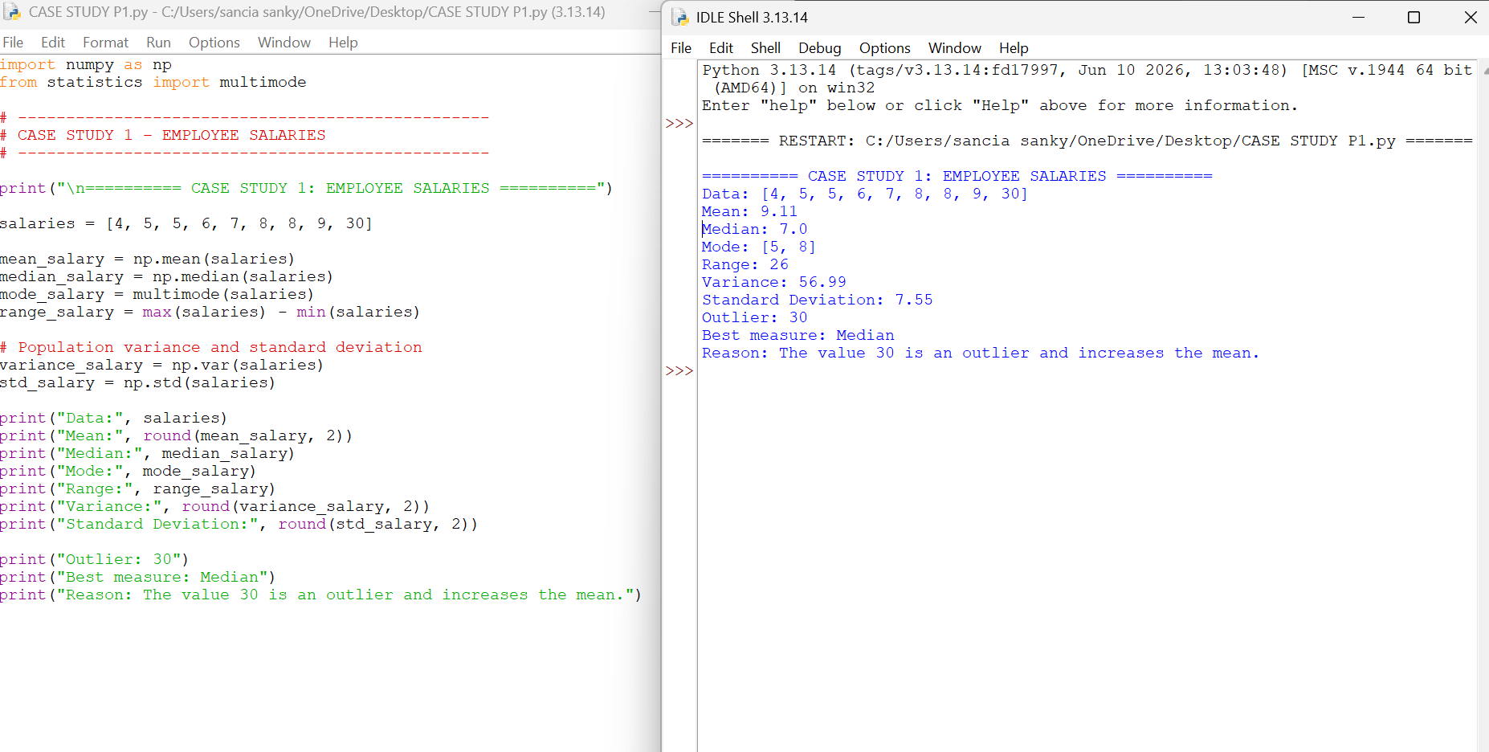
CASE STUDY 2
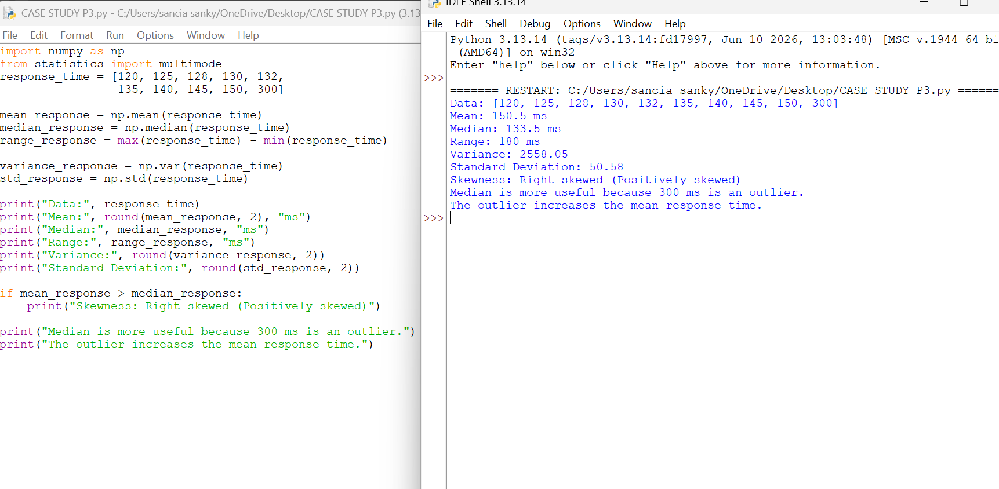
CASE STUDY 3
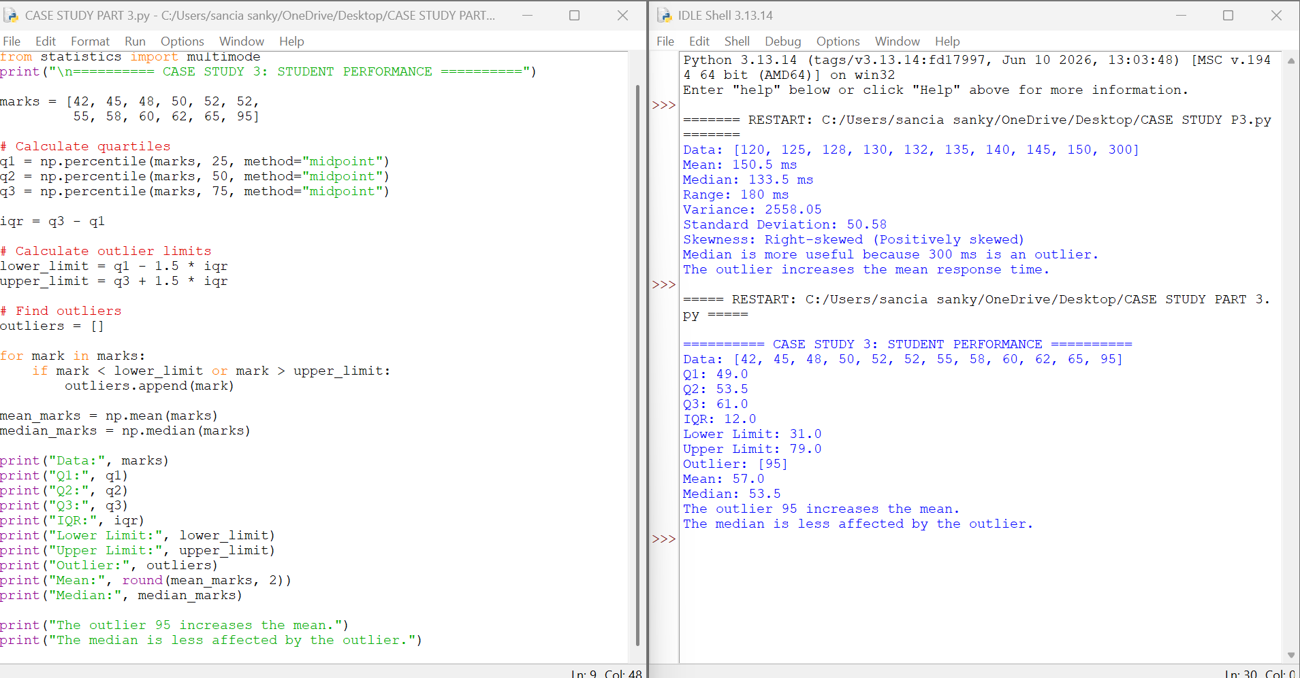
CASE STUDY 4
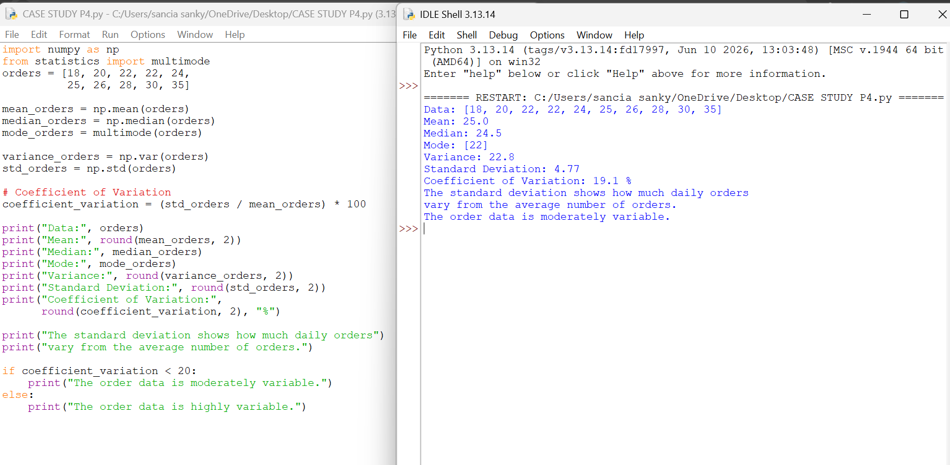

CASE STUDY 5